Impact of Climate Change on Agricultural Productivity in Southern Europe
Martínez-Gómez, Laura¹, Hernández, David², and Petrova, Sofia³
¹ Department of Environmental Sciences, University of Barcelona, Spain
² Institute of Agricultural Research, University of Seville, Spain
³ Faculty of Economics, Sofia University, Bulgaria

Abstract
Maximum 300 words. Lorem ipsum dolor sit amet, consectetur adipiscing elit. Nam metus felis, ultrices at nisl consequat, faucibus ornare orci. Aenean id mauris sit amet magna sollicitudin faucibus. Ut gravida, quam id euismod pellentesque, ipsum metus consequat dui, vel porttitor erat enim nec arcu. Nulla facilisi. Donec sollicitudin lorem id nisi rutrum varius. Vivamus accumsan et turpis lacinia tempor. Vivamus a tincidunt dolor. Integer a blandit risus. Praesent et purus metus. Mauris bibendum est elit, efficitur laoreet mauris varius ac. Integer eget auctor lorem, eget eleifend leo. Sed ut ex eu dolor accumsan sodales. Ut venenatis aliquam sem, id vulputate turpis egestas vitae. Curabitur in eros purus. Cras tristique consectetur massa sed placerat. Curabitur iaculis augue cursus, fermentum felis id, euismod ex.
In maximus viverra tortor, in lobortis neque luctus ut. Suspendisse euismod augue et auctor ornare. Nullam vulputate tincidunt sapien, eget fermentum nisl pellentesque et. Sed sit amet laoreet felis. In at lectus sit amet magna rhoncus feugiat. Sed pellentesque mi arcu, ut mollis lectus fringilla nec. Class aptent taciti sociosqu ad litora torquent per conubia nostra, per inceptos himenaeos. In hac habitasse platea dictumst. Etiam eget tortor dolor. Aliquam volutpat dignissim eros, vel efficitur lorem mattis non.
Vestibulum ante ipsum primis in faucibus orci luctus et ultrices posuere cubilia curae; Nulla non porta odio. Etiam rutrum lacinia urna sit amet ultrices. Cras luctus enim eget sem varius placerat. Donec hendrerit ut sem dignissim tincidunt. Fusce tempor congue mi a ultricies. Cras tempor neque a auctor facilisis. Vestibulum eleifend ante sit.
Keywords (maximum five; separated by semi-colon):
- Introduction
Extension of full manuscript will be between 6-12 pages max. The fonts selected is Times New Roman, Global text size: 11pt. Authors should use the paragraph format established in this template.
Paragraph format example. Tables must be included in an editable version, not as images. Some guidelines: Place tables next to the relevant text. Cite all tables in the manuscript text (Table nº). Number tables consecutively according to their appearance in the text. Please provide concret captions above the tables. Place any table notes below the table body when necessary. Avoid vertical rules and shading within table cells. Figures: Cite all images in the manuscript text (Fig. nº). Number images according to the sequence they appear within your article. Please provide captions for all figures, images.
- Material and Methods
Lorem ipsum dolor sit amet, consectetur adipiscing elit. Nam metus felis, ultrices at nisl consequat, faucibus ornare orci. Aenean id mauris sit amet magna sollicitudin faucibus. Ut gravida, quam id euismod pellentesque, ipsum metus consequat dui, vel porttitor erat enim nec arcu.
Table 1. Example of Caption Table and format
Treatment | pH (-) | EC (µS cm⁻¹) | BDO (mg L⁻¹)
a | 6.2 | 510.0 | 3.72
b | 6.8 | 428.4 | 4.85
C | 7.9 | 750.1 | 8.31
EC: electrical conductivity; BDO: Biological Oxygen Demand
Lorem ipsum dolor sit amet, consectetur adipiscing elit. Nam metus felis, ultrices at nisl consequat, faucibus ornare orci. Aenean id mauris sit amet magna sollicitudin faucibus. Ut gravida.
- Results and Discussion
Lorem ipsum dolor sit amet, consectetur adipiscing elit. Nam metus felis, ultrices at nisl consequat, faucibus ornare orci. Aenean id mauris sit amet magna sollicitudin faucibus. Ut gravida, quam id euismod pellentesque, ipsum metus consequat dui, vel porttitor erat enim nec arcu.
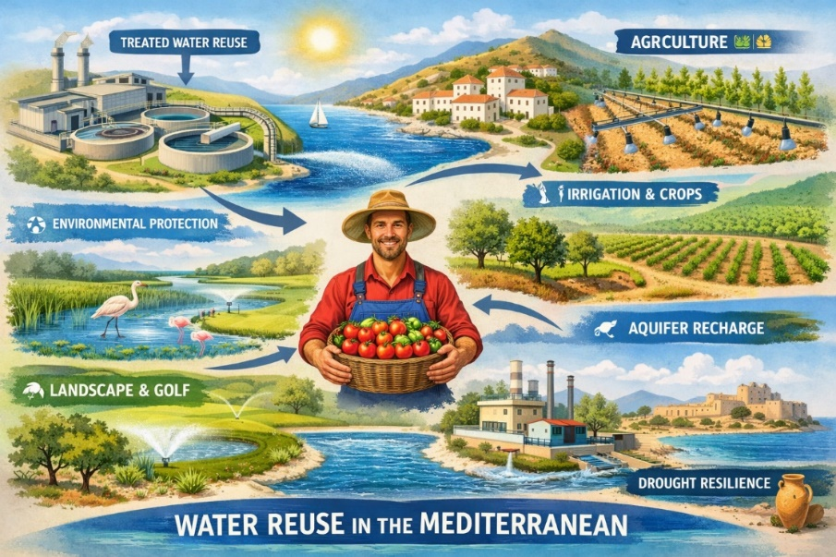
Fig 1. Schematic uses of water resources in the Mediterranean area
Lorem ipsum dolor sit amet, consectetur adipiscing elit. Nam metus felis, ultrices at nisl consequat, faucibus ornare orci. Aenean id mauris sit amet magna sollicitudin faucibus. Ut gravida, quam id euismod pellentesque, ipsum metus consequat dui, vel porttitor erat enim nec.
- Conclusions
Lorem ipsum dolor sit amet, consectetur adipiscing elit. Nam metus felis, ultrices at nisl consequat, faucibus ornare orci. Aenean id mauris sit amet magna sollicitudin faucibus. Ut gravida, quam id euismod pellentesque, ipsum metus consequat dui, vel porttitor erat enim nec arcu.
- Acknodlewgements
Lorem ipsum dolor sit amet, consectetur adipiscing elit. Nam metus felis, ultrices at nisl consequat
- References
References within text
Any references cited within your article should also be present in your reference list and vice versa. Some guidelines:
We recommend that you do not include unpublished results and personal communications in your reference list, though you may mention them in the text of your article.
Any unpublished results and personal communications included in your reference list must follow the standard reference style of the journal. In substitution of the publication date add "unpublished results" or "personal communication."
References cited as "in press" imply that the item has been accepted for publication.

Reference style
All citations in the text should refer to:
- Single author: the author's name (without initials, unless there is ambiguity) and the year of publication.
- Two authors: both authors' names and the year of publication.
- Three or more authors: first author's name followed by 'et al.' and the year of publication.
Citations can be made directly (or parenthetically). Groups of references can be listed either first alphabetically, then chronologically, or vice versa. Examples: "as demonstrated (Allan, 2020a, 2020b; Allan and Jones, 2019)" or "as demonstrated (Jones, 2019; Allan, 2020). Kramer et al. (2023) have recently shown".
The list of references should be arranged alphabetically and then chronologically if necessary. More than one reference from the same author(s) in the same year must be identified by the letters 'a', 'b', 'c', etc., placed after the year of publication.
Abbreviate journal names according to the List of Title Word Abbreviations (LTWA).

Examples:
Reference to a journal publication:
Van der Geer, J., Handgraaf, T., Lupton, R.A., 2020. The art of writing a scientific article. J. Sci. Commun. 163, 51–59. https://doi.org/10.1016/j.sc.2020.00372.
Reference to a journal publication with an article number:
Van der Geer, J., Handgraaf, T., Lupton, R.A., 2022. The art of writing a scientific article. Heliyon. 19, e00205. https://doi.org/10.1016/j.heliyon.2022.e00205.
Reference to a book:
Strunk Jr., W., White, E.B., 2000. The Elements of Style, fourth ed. Longman, New York.
Reference to a chapter in a book:
Mettam, G.R., Adams, L.B., 2023. How to prepare an electronic version of your article, in: Jones, B.S., Smith, R.Z. (Eds.), Introduction to the Electronic Age. E-Publishing Inc., New York, pp. 281–304.
Reference to a website:
Cancer Research UK, 2023. Cancer statistics reports for the UK. http://www.cancerresearchuk.org/aboutcancer/statistics/cancerstatsreport/ (accessed 13 March 2023).
Reference to a dataset:
Oguro, M., Imahiro, S., Saito, S., Nakashizuka, T., 2015. Mortality data for Japanese oak wilt disease and surrounding forest compositions [dataset]. Mendeley Data, v1. https://doi.org/10.17632/xwj98nb39r.1.
Reference to software:
Coon, E., Berndt, M., Jan, A., Svyatsky, D., Atchley, A., Kikinzon, E., Harp, D., Manzini, G., Shelef, E., Lipnikov, K., Garimella, R., Xu, C., Moulton, D., Karra, S., Painter, S., Jafarov, E., & Molins, S., 2020. Advanced Terrestrial Simulator (ATS) v0.88 (Version 0.88) [software]. Zenodo. https://doi.org/10.5281/zenodo.3727209.
Journal publication:
Van der Geer, J., Hanraads, J.A.J., Lupton, R.A., 2010. The art of writing a scientific article. J. Sci. Commun. 163, 51–59.
Oguro, M., Imahiro, S., Saito, S., Nakashizuka, T., 2015. Mortality data for Japanese oak wilt disease and surrounding forest compositions. Mendeley Data, v1. http://dx.doi.org/10.17632/xwj98nb39r.1.
Reference to a book:
Strunk Jr., W., White, E.B., 2000. The Elements of Style, fourth ed. Longman, New York.
Reference to a chapter in an edited book:
Mettam, G.R., Adams, L.B., 2009. How to prepare an electronic version of your article, in: Jones, B.S., Smith , R.Z. (Eds.), Introduction to the Electronic Age. E-Publishing Inc., New York, pp. 281–304.

